Data Preprocessing and Database Design

Now we are proceeding with the data preprocessing phase of the project in a systematic and step-by-step manner. The objective of this phase is to prepare the raw IPL dataset for database implementation by ensuring data consistency, accuracy, and structure.
The preprocessing stage is divided into the following steps:
- Dataset Overview – Understanding the structure of the dataset, including number of records, attributes, and data types.
- Data Inspection – Analysing column details, checking unique values, and identifying inconsistencies.
- Missing Value Handling – Detecting and appropriately handling null or missing values.
- Data Cleaning – Removing duplicate records and correcting formatting inconsistencies.
- Data Transformation – Converting data types and deriving useful attributes such as match year and month.
- Feature Engineering – Creating additional meaningful features to enhance analytical capability.
- Final Pre-processed Dataset – Generating a clean and structured dataset ready for database design.
After completing these steps, the processed dataset will be used to design and implement a normalized relational database using MySQL Workbench8.

1). Dataset Overview: -
The dataset used in this project contains historical match records from the Indian Premier League (IPL). It consists of 816 records and 17 attributes, providing structured information about matches played across multiple seasons.
The dataset includes key attributes such as match ID, city, date, participating teams, toss details, match results, winner, venue, and umpire information. The attributes comprise both numerical variables (e.g., match ID, result margin) and categorical variables (e.g., teams, city, match result).
This dataset provides comprehensive match-level information necessary for performing preprocessing, analytical operations, and database design.

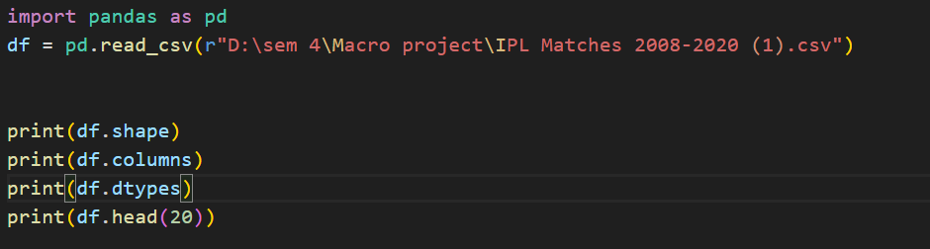

The above code initializes the data preprocessing phase by importing the Pandas library, which is used for data manipulation and analysis in Python. The dataset containing IPL match records is loaded into a DataFrame using the read_csv () function.
Once the dataset is successfully loaded, basic exploratory commands are executed to understand the structure and contents of the data:
- df.shape: displays the total number of rows and columns in the dataset.
- df.columns: lists all column names, helping to understand the attributes present.
- df.dtypes: shows the data type of each column, which is important for identifying incorrect or inconsistent data formats.
- df.head(20): displays the first 20 rows of the dataset to visually inspect sample records.
These steps help in gaining an initial understanding of the dataset before proceeding with detailed data inspection and cleaning.

OUTPUT: -

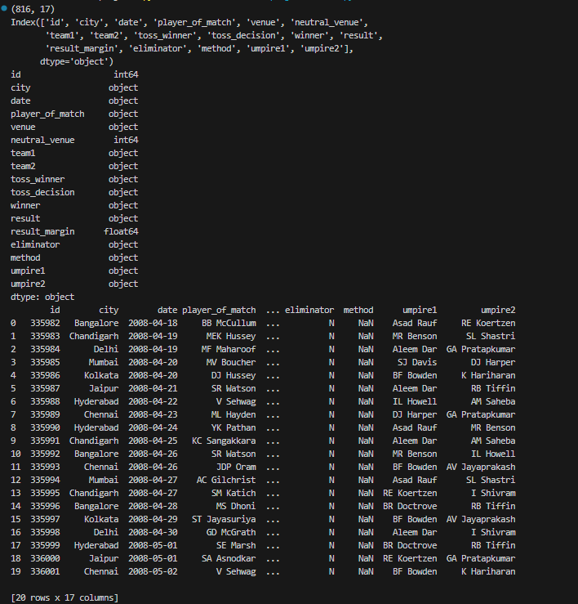

2). Data Inspection: -
After understanding the basic structure of the dataset, the next step is data inspection. This stage focuses on examining the internal details of the dataset to identify inconsistencies, missing values, and potential data quality issues before performing cleaning operations.
Data inspection helps in analysing the completeness, distribution, and uniqueness of the data.
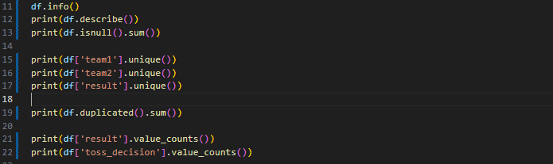
Description of the Inspection Steps:
- df.info ()
Displays a summary of the dataset including column names, non-null values, and data types. This helps in identifying missing values and incorrect data types.
- df.describe()
Provides statistical summary (mean, min, max, standard deviation, etc.) for numerical columns such as match ID and result margin.
- df.isnull(). sum ()
Shows the total number of missing values in each column.
- df['team1']. unique () and df['team2']. unique ()
Displays unique team names to detect inconsistencies in naming formats.
- df['result']. unique ()
Identifies possible match outcomes such as runs, wickets, tie, or no result.
- df.duplicated(). sum ()
Checks the number of duplicate records in the dataset.
- Value_counts()
Shows the frequency distribution of categorical variables like result type and toss decision
OUTPUT: -
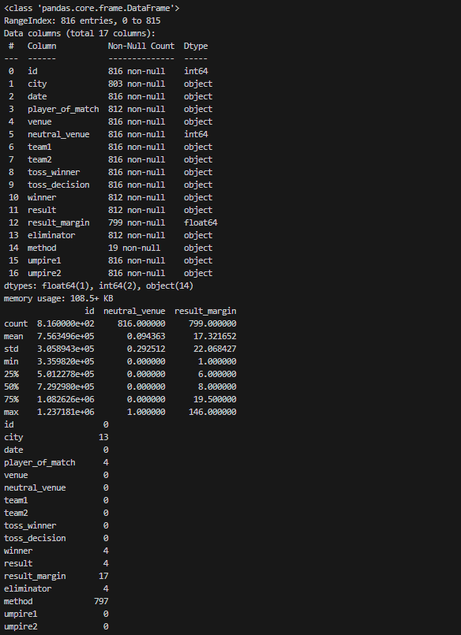

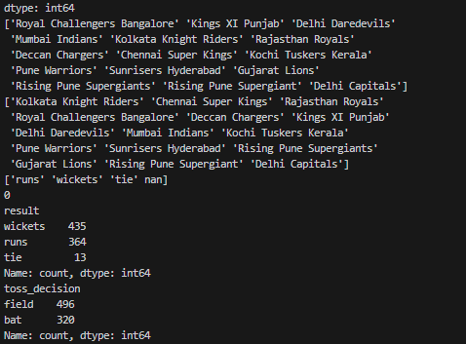

3). Missing value handling: -
After inspecting the dataset, the next step is handling missing values. Missing data can affect analytical accuracy and database integrity. Therefore, it is important to identify and treat null values appropriately based on the context of each column.
In this dataset, certain columns such as city, player_of_match, method, and result_margin contain missing values. Instead of removing rows, suitable default values are assigned to preserve important match records.
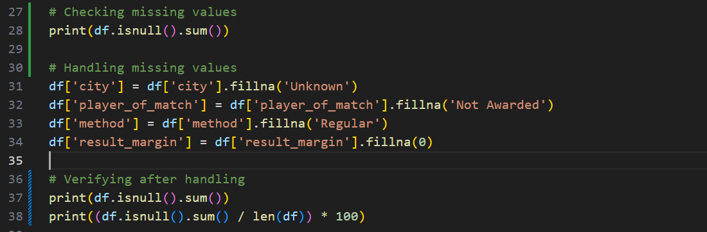
Description of the Steps:
- df.isnull(). sum ()
Identifies the number of missing values present in each column.
- City column
Missing values are replaced with "Unknown" since the city information was not recorded for some matches.
- player_of_match column
Missing values are replaced with "Not Awarded" to indicate matches where no award was given.
- method column
Missing values are replaced with "Regular" to indicate standard match completion.
- result_margin column
Missing values are replaced with 0 since some matches (e.g., ties or no result) do not have a winning margin.
- Percentage Calculation
The percentage of missing values is calculated to confirm that all null values have been handled.
OUTPUT: -
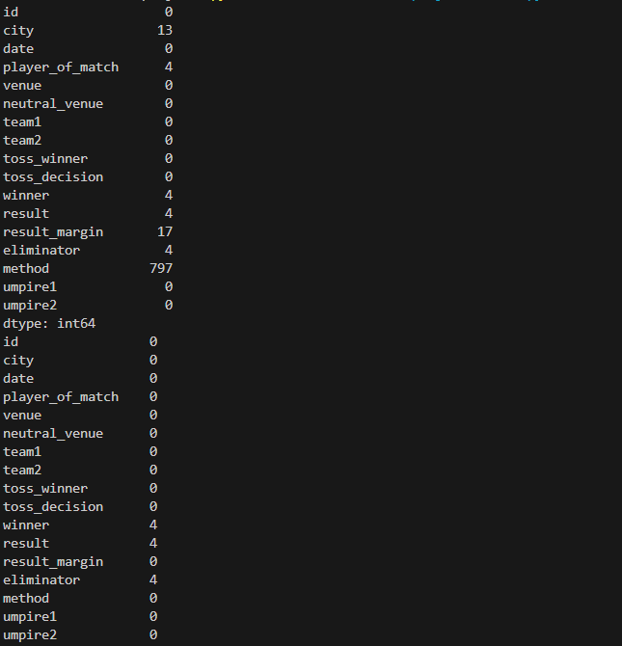
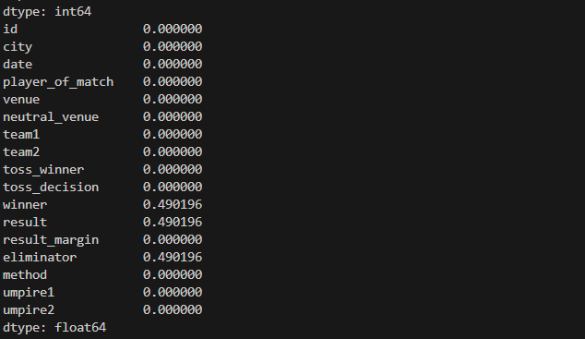
After handling missing values, the dataset becomes complete and free from null entries. This ensures that the dataset is ready for further cleaning, transformation, and database implementation without integrity issues.

4). Data Cleaning: -
After handling missing values, the next step is data cleaning. This stage ensures that the dataset is free from duplicate records and formatting inconsistencies that could affect database integrity and analysis.
Data cleaning improves data quality by standardizing text fields and removing redundant entries.
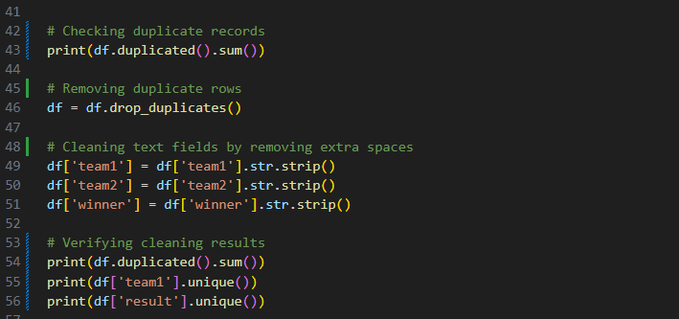
Description of the Steps:
- df.duplicated().sum()
Checks the total number of duplicate records in the dataset.
- df.drop_duplicates()
Removes duplicate rows to ensure each match record is unique.
- str.strip()function
Removes leading and trailing spaces from categorical columns such as team1, team2, and winner.
This prevents issues during grouping, filtering, or database foreign key mapping.

- Verification
After cleaning, duplicate count is rechecked and unique values are printed to confirm consistency.

OUTPUT: -
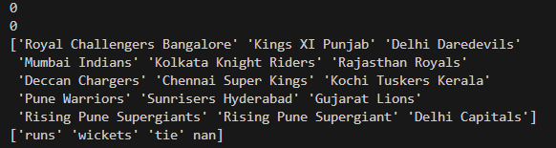
After performing data cleaning:
- Duplicate records are removed.
- Text inconsistencies are corrected.
- Categorical values are standardized.
This ensures that the dataset is consistent, reliable, and ready for transformation and database implementation.

5). Data Transformation: -
After cleaning the dataset, the main transformation phase begins. In this stage, the data is converted into appropriate formats and structured attributes are derived to enhance analytical capability and ensure consistency across the dataset. This includes converting date columns into datetime format, extracting meaningful components such as year and month, and standardizing categorical variables for clarity.
Data transformation ensures that the dataset is properly structured for relational database implementation and advanced querying. By refining data types and creating derived attributes, the dataset becomes more organized, analysis-ready, and suitable for efficient storage and performance evaluation.
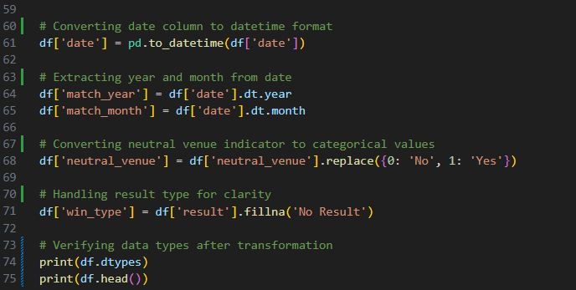

Description of the Steps:
- Date Conversion
The date column is converted from object type to datetime format using pd.to_datetime().
This allows time-based analysis and extraction of temporal features.
- Feature Extraction (Year and Month)
New columns match_year and match_month are created to enable season-wise and month-wise analysis.
- Neutral Venue Transformation
The binary values (0 and 1) are converted into meaningful categorical labels (“No” and “Yes”) for better interpretability.
- Result Handling
Missing results are replaced with “No Result” to clearly represent tied or abandoned matches.
- Verification
The data types are printed again to confirm that transformation has been applied correctly.

OUTPUT: -
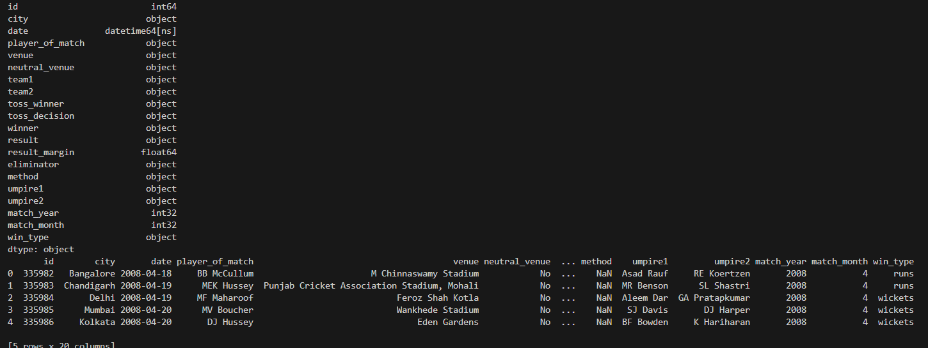
After transformation:
- Date is properly formatted.
- New analytical attributes are created.
- Categorical fields are standardized.
- Dataset becomes structured and analysis-ready.
This stage marks the transition from basic cleaning to structured analytical preparation, making the dataset suitable for feature engineering and database design.

6). Feature Engineering: -
After completing data transformation, the feature engineering phase begins. In this stage, new meaningful attributes are created from existing columns to enhance the analytical depth of the dataset. These derived features help in identifying match patterns, performance trends, and strategic factors influencing outcomes.
Feature engineering improves the dataset by generating calculated indicators that simplify analysis and improve database querying efficiency. These additional attributes make the dataset more structured and suitable for advanced performance evaluation.
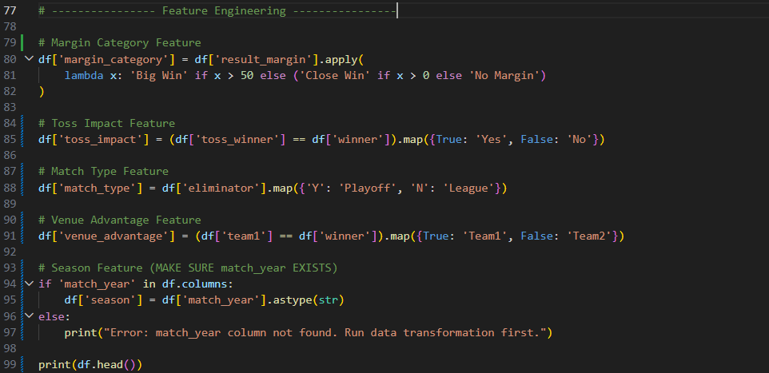

Description of the Steps:
- margin_category
Classifies matches into "Big Win", "Close Win", or "No Margin" based on the winning margin.
- toss_impact
Determines whether the team that won the toss also won the match.
- match_type
Converts eliminator indicator into meaningful categories: "Playoff" or "League".
- venue_advantage
Identifies whether Team 1 or Team 2 won the match.
- season
Converts match year into a season identifier for seasonal analysis.
OUTPUT: -
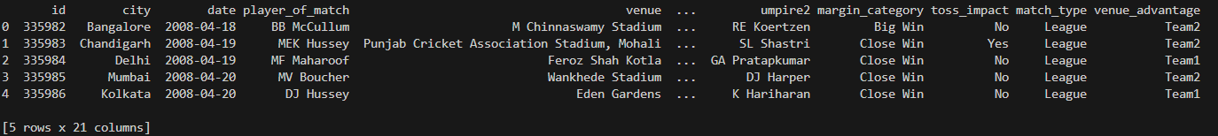
After feature engineering, the dataset contains additional analytical attributes that improve interpretability and querying capability. These engineered features enhance performance analysis and prepare the dataset for efficient relational database implementation.
7). Final Pre-Processed Dataset: -
After completing missing value handling, data cleaning, transformation, and feature engineering, the dataset reaches its final structured form.
At this stage, all inconsistencies have been removed, data types have been corrected, and new analytical features have been successfully derived. The dataset is now fully prepared for relational database storage, advanced querying, and performance analysis.
This final validation step ensures:
- No missing values remain
- No duplicate records exist
- All derived columns are correctly created
- Dataset structure is consistent and analysis-ready
The final dataset is then exported as a new CSV file to be used for database import and further SQL operations.
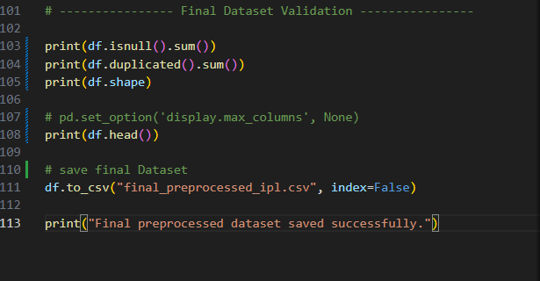

DATABASE DESIGN
After completing the data preprocessing phase, the next crucial stage of the project is the design and implementation of a structured relational database for efficient storage and management of the IPL dataset. While the preprocessed dataset is clean and analysis-ready, storing it in a single flat table would lead to redundancy, limited scalability, and inefficient querying. Therefore, a proper relational database design is essential to ensure structured organization, consistency, and long-term maintainability of the data.
The primary objective of the database design phase is to decompose the dataset into multiple logically related tables following normalization principles. This approach helps in reducing data redundancy, avoiding update anomalies, and maintaining referential integrity through the use of primary and foreign key constraints. By separating entities such as teams, players, venues, and matches into distinct tables, the database ensures that repetitive information (for example, team names or venue names) is stored only once and referenced wherever required.
Additionally, designing a relational schema improves query performance and analytical flexibility. Complex queries such as team performance analysis, venue-based statistics, player achievements, and toss impact evaluation can be efficiently executed using JOIN operations across normalized tables. The structured design also supports scalability, allowing future integration of additional seasons or extended match-level statistics without restructuring the entire database.
Instead of maintaining all attributes within a single large table, the dataset is systematically normalized into interconnected relational tables. Each table represents a specific entity, and relationships between them are established using foreign keys. This structured approach ensures data consistency, enhances performance, and aligns the project with real-world database management practices.
Through this phase, the project transitions from a cleaned analytical dataset to a fully functional relational database system capable of supporting structured querying, reporting, and performance evaluation.

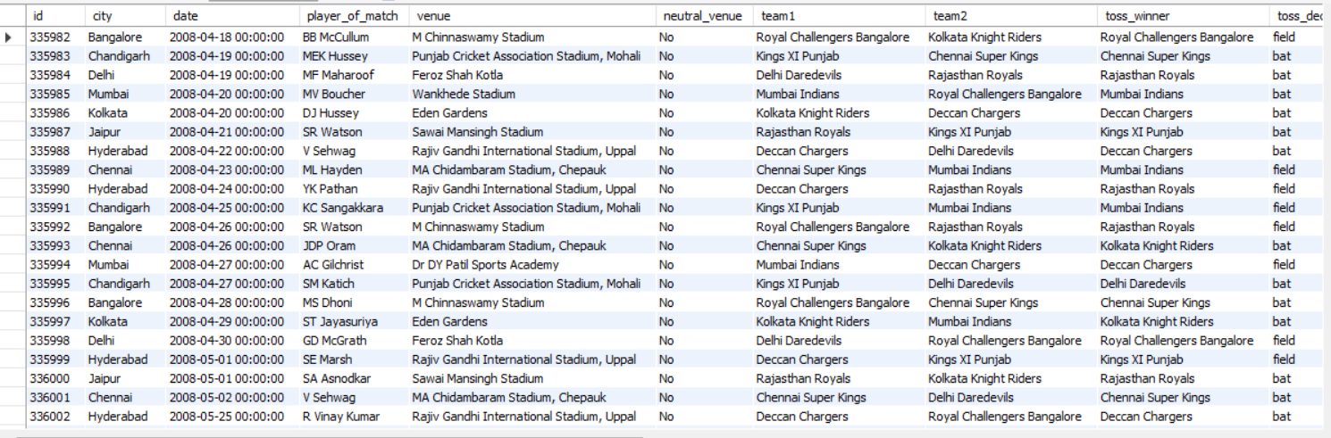
the database design phase was carried out in a structured and systematic manner. The following steps were performed:

1). Creating the Database: -
The first step was to create a dedicated database environment to store the IPL dataset. This ensures proper separation of project data from other databases and maintains organized data management.
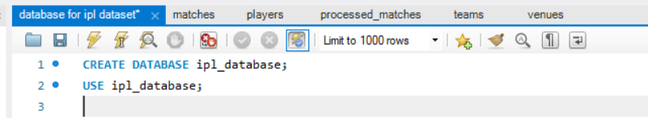

2). Create Tables: -
Based on the dataset structure, the main entities were identified:
- Teams
- Players
- Venues
- Matches
Each entity represents a real-world object in the IPL ecosystem.
- Teams table: -
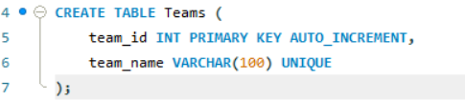
- Players table: -
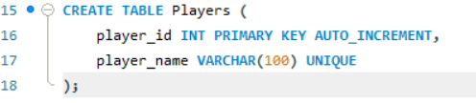
- Venues Table: -
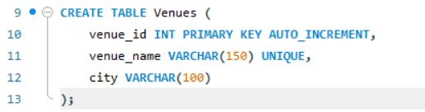
- Matches Table: -
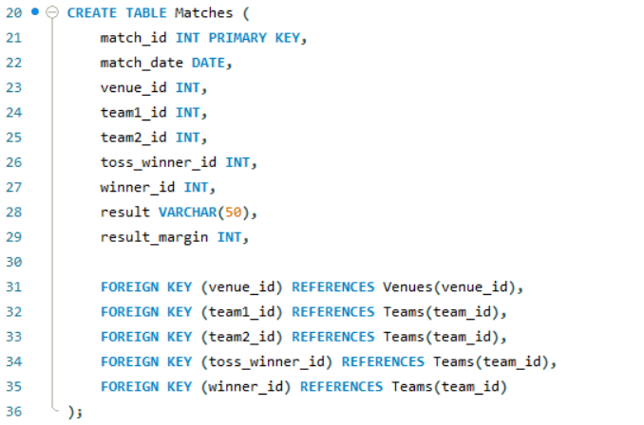
3). Insert Data into Tables: -
After creating the relational tables, the next step was to populate them with data from the processed dataset. The dimension tables Teams, Venues, Players and Matches were filled first using distinct values to ensure that each entity is stored uniquely and duplication is avoided.
Once these tables were successfully populated, the Matches table was inserted by mapping the appropriate foreign key references from the related tables. This structured insertion process maintains referential integrity and prepares the database for efficient querying and analytical operations.

After creating all relational tables, the next step was to populate them with data from the processed dataset. The insertion was performed in a systematic order to ensure proper relational mapping and maintain database integrity.

1). Insert Teams: -
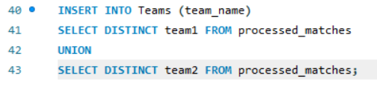
2). Insert Venues: -
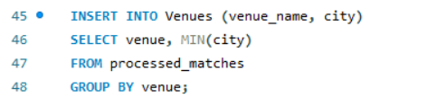
3). Insert Players: -
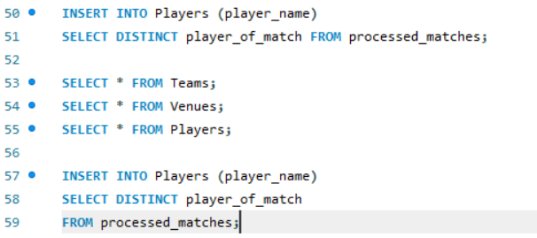
4). Insert Matches: -
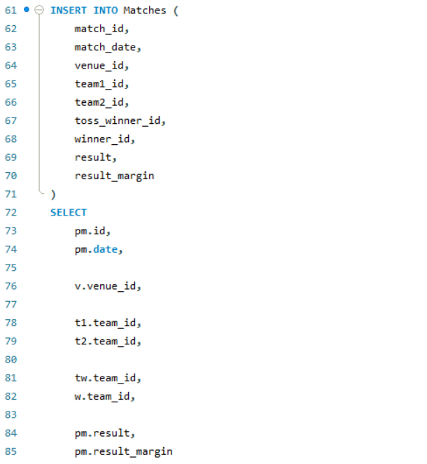
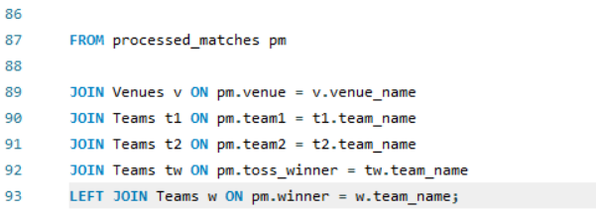
4). DataBase Validation: -
After successfully inserting all records into the relational tables, the final step involves validating the database to ensure accuracy, consistency, and integrity. Database validation confirms that all tables are correctly populated, foreign key relationships are properly established, and no unintended errors occurred during insertion.
This step includes verifying record counts, checking referential constraints, and executing sample queries to confirm that data relationships are functioning as expected. Validation ensures that the database structure is reliable, consistent, and fully ready for analytical querying and performance evaluation.
Through this process, the integrity and correctness of the relational database design are formally confirmed.
1). Count Matches: -
2). Check Foreign Key Linking: -
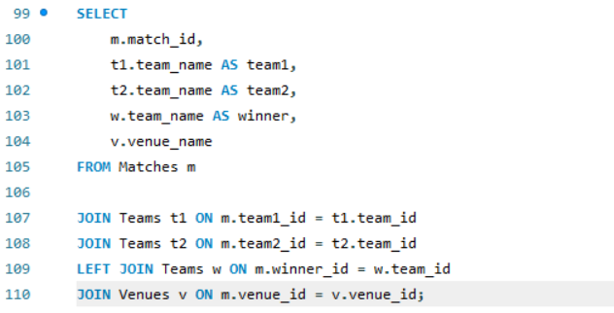
3). Sample Analytical Query
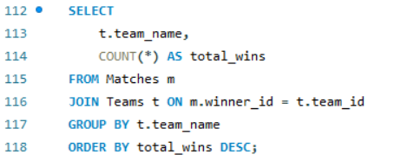
CONCLUSION: -
The Data Analytics System for IPL (Sports System) project successfully demonstrates the complete lifecycle of transforming raw sports data into a structured, relational, and analytics-ready database system. The project began with importing historical IPL match data and performing detailed data preprocessing, which included dataset inspection, missing value handling, data cleaning, transformation, and feature engineering. Through these steps, the raw dataset was refined into a consistent and structured format suitable for advanced analysis.
During the preprocessing phase, inconsistencies were removed, missing values were handled systematically, duplicate records were eliminated, and relevant analytical features such as match year, margin category, toss impact, and match type were derived. These enhancements improved the dataset’s analytical depth and prepared it for structured storage and querying.
Following preprocessing, the project transitioned into the database design phase. The dataset was normalized into multiple relational tables — Teams, Players, Venues, and Matches — to eliminate redundancy and maintain referential integrity. Primary and foreign key constraints were implemented to establish strong relationships between tables, ensuring data consistency and structured organization.
Data was then inserted into the database in a sequential manner, beginning with dimension tables and followed by the central Matches table using proper foreign key mapping. Finally, database validation was performed to verify record counts, integrity constraints, and relational accuracy. Analytical SQL queries were executed to demonstrate the database’s capability to generate meaningful insights such as team performance and match outcomes.
Overall, this project successfully integrates data preprocessing techniques with relational database design principles to build a scalable and efficient sports analytics system. The final system not only ensures structured data storage but also supports advanced querying, performance evaluation, and future analytical expansion.
This project reflects a practical implementation of data analytics concepts, database normalization, relational modeling, and structured querying within a real-world sports domain.

